# **Course Project – American Airlines Predictive Maintenance**

# Problem Statement

## Background

The case which I have decided to focus on for my project is called “Overcoming the Challenges of Aircraft Engine Maintenance and Repair.” Selected from one of the websites provided to us in the project description page, I found it quite intriguing, partly because of my own experience from flying. Several months ago, I was flying from Orlando to Toronto and my flight was cancelled, requiring all passengers to sleep in the terminal overnight before being rescheduled for the following morning. Ultimately, it was due to an aircraft maintenance issue which could have been remedied had better planning gone into it. And what I found even more curious after digging deeper into this specific case study was that there was very little devoted to the cost of delays resultant from lost revenue due to customer dissatisfaction. I hope to devise an analytics-based solution that optimizes for a minimum in lost revenue arising from both planned and unplanned repairs and maintenance of aircraft.

## Problem Description

*”The planning of spare engines and engine parts is a challenging and important task for airlines to seamlessly support flying and engine repair operations. Engines are expensive and critical assets that make this problem important from the financial and operational perspectives. We present an application of an analytics-based approach utilized for planning the ownership level of spare engines and engine parts required to achieve a target service level or out-of-service (OTS) aircraft performance metrics.”*

## Breaking It Down

The problem that American Airlines was experiencing was quite complex in nature, but I have tried to simplify it to the best of my abilities. Aircraft need to undergo regular maintenance repairs but also must be repaired due to unplanned equipment issues. While AA keeps a variety of equipment at different sites, much of their extra parts and engines reside in a centralized location at the “Pool Shop” in Tulsa, Oklahoma. For both unplanned and planned repairs/maintenance, the aircraft is often sent to Tulsa for repair. After being repaired and inspected, it is then able to enter back into regular service. In a perfect world, the center at Tulsa would have all the equipment as needed to repair the aircraft as fast as possible. However, an engine alone can have alone 800 separate parts and given that there are different types of aircraft that AA has in it’s fleet, all with different components in the aircraft with each of it’s own separate parts, it’s not feasible for the company to keep all parts on hand. However, when a part is missing, it significantly increases repair time and repair time variability and not having the parts when needed can result in huge losses.

Our goal is to be able to find the combination of parts and their quantities which minimizes lost revenue.

This problem can be broken down into three components:

* Step 1 - Modelling our Costs (OTS Metrics)
* Step 2 – Forecasting Demand for Repairs
* Step 3 – Final Optimization (Building Prescriptive Model)

The first step helps us understand, define and measure the costs of each possible outcome relating to equipment failure.

The second step of the process requires us to forecast demand for planned repairs and maintenance as well as determine the failure rates of the different aircraft components.

The third step of the process, arguably the most time-consuming, is building out a prescriptive model which optimizes for total cost.

Let us dive in!

# Step 1 – Modelling our Costs

# Analysis

Before we get into procurement of any data related to our predictive or prescriptive models, it’s important to measure the different costs associated with each possible outcome for equipment failure. The team at AA defined for themselves OTS Performance Metrics (Out-of-Service) so let us try to unpack that.

First, let us just remind ourselves what is in our control. We can choose what equipment to purchase and how much of each part to purchase. Our goal is to choose the right combinations of these variables to reduce overall cost.

There are two types of repairs/maintenance – planned and unplanned. For planned repairs, the inventory which is expected to be replaced can be stocked and ready to be used at a moment’s notice. This is relatively easy to predict. However, it is the unexpected repairs that are more difficult to predict and choose given the complex analytical modelling required. Unexpected repairs would require the aircraft to be flown into the Tulsa headquarters, repaired and inspected before it was ready to be in-service again. The costs to the airline from unexpected groundings can be broken down into three types of cost.

**Operational:**

There are likely to be many operational costs associated with repair and aircraft maintenance, but the biggest factor is by far the costs of keeping an in-service plane grounded. Time is money in the aviation industry, and the longer a plane stays out of service, the more it costs the airline. It may require re-routing that aircraft’s flight, or worse, cancel its flights. And if repair times stretches from days to weeks, this can turn into a huge loss in revenue.

**Customer Costs:**

Costs to customers associated with unplanned aircraft repairs may greatly range and could be quite large if not carefully managed. If a flight is delayed or cancelled because of unplanned aircraft repairs, then costs to customers which indirectly will be costs the company (from customers opting for other airlines in the future) may be quite large. As I mentioned, my own experience from a cancelled flight due to an aircraft repair issue left me quite dissatisfied with the service and I try to avoid flying on that airline. And if there are enough of these incidents, the short-term damage to a company can compound into even larger costs. For example, many people now choose not to fly on United Airlines given their overall poor reputation and so we should try and quantity customer cost if possible.

**Service Costs:**

There are of course service costs associated with each repair or maintenance routine which depends greatly on the plane, the location of the plane, and the nature of the repair. Costs can include the hourly cost of workers, the cost of the equipment itself, the fixed cost of transporting the aircraft to and from the repair site, etc.

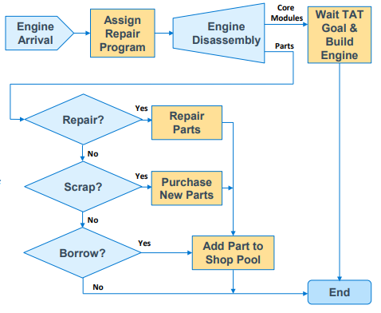

Figure - Process Flow Diagram for an Engine Repair

Now that we have looked at the different types of costs, let us examine the different scenarios for when a repair needs to be performed.

There is a cost to of course purchasing all this equipment, a potential cost of not using the equipment, and of not having the equipment when needed:

**Scenario 1: Costs of having the part and the repair**

In this scenario, the part is available and ready to use for repairs on an aircraft.

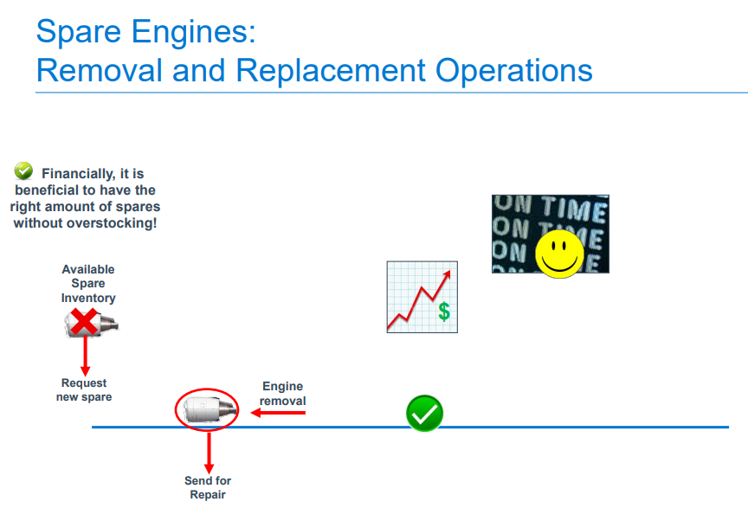Operational Cost: In this scenario, there are likely to be the least operational costs as there will be no delays arising from any missing parts. The repair would hopefully take place immediately and then returned to service. There is also likely to be little variance in repair times in this scenario.

Customer Cost:

While there may be some customer cost, this may be unavoidable. Hopefully, it will mitigate some of the potential cost resultant from cancelled flights.

Service Repair Cost: There is no additional repair or service cost other than the fixed service or repair cost.

Ultimately, this is the most desirable outcome and is the most efficient of the three scenarios.

**Scenario 2: Costs of not having the part and the repair**

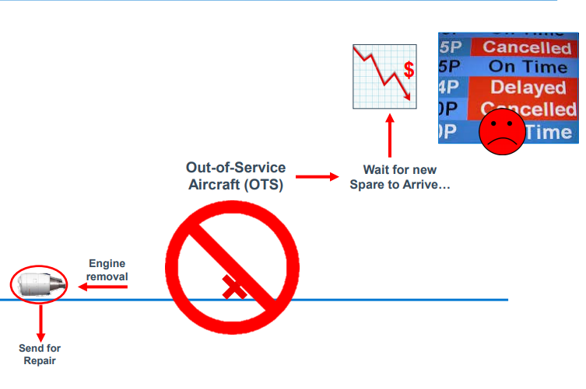This is when the repair equipment is not at the location and must be ordered or rented from another place (whichever is cheaper and available)

Operational Cost: The operational costs are much larger in this scenario. If the part is ordered, it may take time to arrive and time is money in this context. The variance in repair times may also be quite large. If it is rented, then it will be at a premium and additional maintenance may again be needed.

Service Repair Cost: The repair and service costs may be large, and if an entire component is replaced rather than just the individual component (e.g. full engine replaced rather than a part of the engine), that can increase service and repair costs.

**Scenario 3: Costs of Extra Parts**

This is when there are extra parts at the service center not being used. While having extra parts may be better than not having the parts when needed, we still don’t want to be in a situation where there are extra parts lying around as the equipment is likely to be expensive (engines for example can cost up to a million dollars each) and requires warehouse space. If the equipment becomes outdated or cannot be used, then the money spent to purchase the equipment was not spent efficiently. Why have four spare engines at the Shop Pool when you will likely only be needing two?

# What data do we need?

The integral data that I believe is required for the first part of the analysis includes:

Operational Cost:

* Cost of transporting each type of aircraft to and from repair site (per hour)
* Fixed Costs of Cancelled flights (depending on flight type)
* Variable Costs for Delayed Flights (depending on flight type)

Customer Cost:

* Cost to Customers from cancelled flights – Would need an customer experience expert to figure out what data is required to quantify this cost.

Service/Equipment Cost:

* Price of each type of part
* When each part can be expected to arrive after an order is made (mean and standard deviation)
* Repair times (mean, and standard deviation) and man-hours (mean, and standard deviation) required for repair and number of required personnel for each type of equipment failure.

While this may be relatively simple, it is an enormous amount of data to obtain. We can expect that for many of the parts we will not be able to gather all the information and so will need to impute the data.

Intuitively, I believe that prices will be relatively easy to obtain. What may be difficult is to determine when a part can be expected to arrive after an order is made, and the man hours needed for each type of failure. Additional data including manufacturer, type of part etc. is likely to greatly help in the imputation process.

# What model(s) can we use?

To impute the data, I believe a factor-based regression model can be used. For example, if we do not know when a part can be expected to arrive after an order is made, we might be able to use the manufacturer data, the type of part and other such information to predict how long it might take. For repair times, we should be able to use the same kind of data to predict repair times.

While any regression-based algorithm should work, I believe that a decision tree or a random forest might work well. A decision tree’s first branch for example may be the manufacturer. Perhaps some manufacturers take longer in sending parts and manufacturer would be one the first factors in determining how long it might take followed by other branches based on other data.

Step 2 – Forecasting Demand for Repairs

# Analysis

After acquiring the data from step 1, it is now time to model both the demand for parts that will be used during regular maintenance and repairs as well as the failure rates of aircraft parts.

Let us start by focusing on the first component of the above statement – modelling the demand for parts that are to be used in regular maintenance and repairs. As mentioned, while much of the difficulty in solving this issue is related to the unexpected repairs, planning for expected repairs and maintenance is still required as part of our solution.

AA is likely to have a maintenance schedule for each aircraft which is likely to be primarily dependent on the type of aircraft (Manufacturer and Model) as well as number of hours flown. Our job is to predict what kind of fleet AA should have at any given time, so that the parts are ready for scheduled repairs and maintenance. This will not require predictive modelling as much as gathering data related to AA purchases and expected delivery times of new aircraft and plotting a schedule of their fleet. From this, the equipment needed for expected repairs and maintenance can be ordered.

The second component, which has been our primary focus is, unsurprisingly, more challenging. Modelling the failure rates of each individual aircraft part is quite complex, but I believe we have learned the necessary tools to model such failure rates.

# What data do we need?

The data required for the second part of our analysis will require us to gather maintenance and repair records, ideally for as many airlines and stretching back 20+ years. AA of course should be able to requisition its own records for 20+ years. And if there is a centralized place where all maintenance and repair records are stored from other airlines, the additional data would help make our models even more accurate.

# What model(s) can we use?

As we covered in Lesson 13.3, the Weibull Distribution can be used to model the time between failure rates. As I do not have the data required for this analysis myself, I cannot tell you exactly what the parameters of the Weibull Distribution would be, or what the Weibull Distribution would resemble. But intuitively, I would predict that the parameter K would be greater than 1, where failure increases with time. As a plane ages, I would think that the aircraft parts are more likely to fail which means K > 1.

Software should be able to help us determine the exact type of distribution and the parameters of our failure rates. As Professor Sokol mentioned however, we should be cognizant of the fact that software may overcomplicate our models and be make quite sure that the predicted distributions are indeed accurate and appropriate.

There is one difficulty I foresee during the modelling process in this step. As each aircraft has 1000s of different components and parts, and there will likely be not be a substantial amount of data for each of the components, I think it’s very likely that there will be a substantial amount of missing data. For newer aircraft for example, we may not have repair and maintenance records for that aircraft since it may not have been in service with the airline very long. We once again cross the question of what to do with missing data?

There are of course several methods we can employ include introducing a categorical variable, discarding incomplete data, imputation etc. I believe the best approach would be to use factor-based imputation, just as we did in Step 1. Using variables such as type of engine part and manufacturer, we should be able to predict the failure rate of engine parts with a reasonable degree of accuracy. For example, if we don’t have the failure rate for Engine Part A, manufactured by company C, we should be able to make a reasonable prediction for the failure rate of that part based on the failure rates of Engine Part A made by other manufacturers and also the reliability of Company C.

Step 3 – Final Optimization

# Analysis

In this final step, our goal is to minimize cost by optimizing for what part we want to keep on-hand at the Shop Pool and the quantity of each part. To determine whether it is worth keeping a part on-hand ultimately boils down to, does the cost of not having the part when needed (calculated in Step 1) multiplied by the probability it will be needed (calculated in Step 2) exceed the cost of ordering the part and not using it (calculated in Step 1) multiplied by the probability it will not be used (calculated in Step 2). In other words, if the value from the first half of the statement exceeds the second half of the statement, then it is worth ordering the part. If not, then it is not worth ordering the part.

If we were dealing with absolute probabilities, then it may have been possible and practical to use optimization to solve this problem. However, we are not working with absolute probabilities but failure rates. This makes the problem a lot more challenging to optimize for. As we came across when learning about queueing theory, trying to optimize for complex distributions is quite difficult and convoluted. Furthermore, there are several other complexities in this particular example which may be difficult to incorporate in an optimization model. One example being, if there are too many repairs then the repair site at Tulsa may require a queue to be formed for aircraft needing to be repaired. Other complex details that AA has cited in this problem description include borrowing of parts, scrapping, capacity constraints and engine harvesting processes.

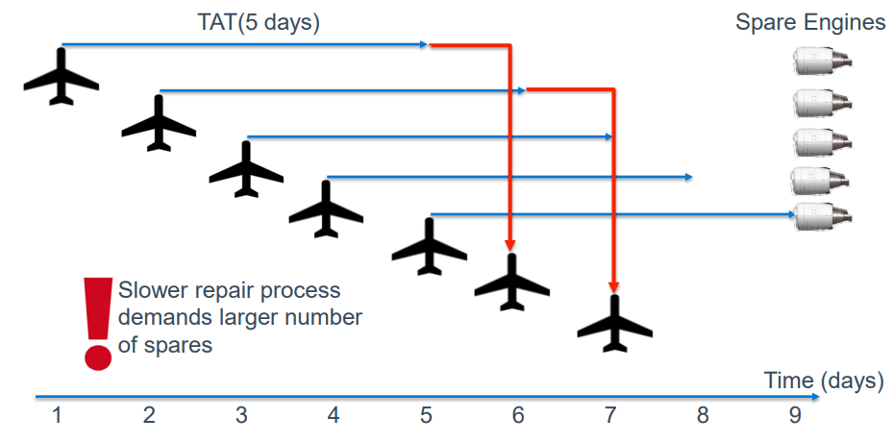

Figure - Backlog Example

I believe that the next best solution would be simulation. This would also allow AA to model the high variability regarding repair times and demand for parts, both of which AA made clear in their problem description. I think the implementation of our simulation-based approach would be in two steps.

In our first step, we could filter out parts where it makes clear sense to have parts available at the Shop Pool. For those parts that have a high probability of needing to be replaced or repaired and which do not have a significant cost upfront, it would make sense to include those. We could use our probability distributions, calculating for the probability of it failing up until the time the time the aircraft is no longer expected to be in service. By calculating cost on both ends, for both scenarios when the part is not on-site or is on-site, if the cost of not having it on site far exceeds having it on-site, we can automatically keep it part of our simulation.

Our second step would be to create a simulation of AA’s flight schedule, including all the flight routes with the correct plane and each possible part’s failure rate embedded in the simulation. By performing several simulations, and varying the quantities of our parts, we could determine the optimal quantities for our various aircraft parts. Make no mistake that with a 1000 aircraft in service at AA and more than 300,000 passengers a day, implementing our simulation would be quite complex as well time-consuming. However, this solution in my opinion remains the most accurate and efficient.

# What data do we need?

Fortunately, the data-gathering step of this process is not too intensive. To model our simulation accurately, we would need the number of employed mechanics at the Tulsa location, the number of repairs AA can perform simultaneously and flight schedules with aircraft specifications and number of hours they have been in service. In addition, data from our previous 2 models which gives us the failure rates and the costs associated with each possible scenario of equipment failure is required.

We may also need to transform our Weibull Distribution into a Cumulative Hazard Rate which may resemble something like the example plot below. The cumulative hazard rate is the area under the curve of our failure/hazard rate.

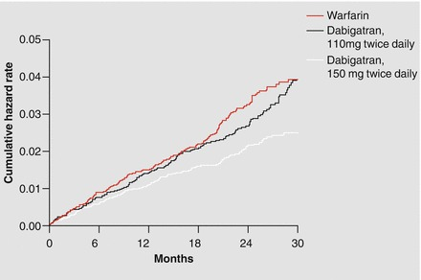

Figure - Cumulative Hazard Rate Example

# What model(s) can we use?

# As noted in the Analysis portion, simulation is both the analytical approach and the model which we can use to optimize for minimum cost. Arena, which has been used for airport modelling, should be an appropriate software for our simulation.

Conclusion

I believe this 3-step process should enable us to optimize for cost by informing us which parts should be kept in the Pool Shop and the quantity of those parts. The AA operation issue has a few additional complexities beyond the scope of this assignment. For example, modelling a distributed inventory system (multi-location) rather than a centralized inventory (single location). We may want spare parts at some of the other smaller repair sites or even at airports rather than storing all of them at Tulsa. Specifically, relating to engines, there are complexities to account for such as Engine Overhaul and harvesting schedules for engines which is beyond the scope of this assignment. Capacity constraints, which are not detailed in the problem description, may also need to be considered. However, with this approach and by specifically using simulation, we should be able to incorporate all these complexities versus an optimization model approach which may not allow for such complexities or would be impractical.

**References:**

Informs. (n.d.). Overcoming the Challenges of Aircraft Engine Maintenance and Repair. Retrieved from https://www.informs.org/Impact/O.R.-Analytics-Success-Stories/Overcoming-the-Challenges-of-Aircraft-Engine-Maintenance-and-Repair